Ex: 01 DEGINE A BASIC WEBPAGE USING HTML & CSS Date: 11.12.2025
Name: Ajay Kumar S
Roll no: 2024503701
Aim:
To design a basic webpage using HTML and CSS.
Description:
The webpage is created using various HTML and CSS tags. Below are the tags used along with a short description:
HTML Tags Used:
- <html> – The root element of an HTML page.
- <head> – Contains metadata, title, styles, and links used in the webpage.
- <body> – Contains all the visible content shown on the webpage.
- <h1>, <h2>, <h3>, <h4> – Heading tags used to display titles and subheadings.
- <hr> – Inserts a horizontal line for separation.
- <img> – Used to display images on the webpage.
- <p> – Defines a paragraph of text.
- <a> – Hyperlink tag used to link to external websites.
- <label> – Text associated with form input fields.
- <input> – Used to take user input such as text, number, checkbox, radio, and submit.
- <ul> – Unordered list to display bullet points.
- <ol> – Ordered list to display numbered items.
- <li> – List items inside ul or ol.
- <marquee> – Used to create scrolling text or images (deprecated tag).
- <table> – Used to display data in tabular form.
- <th> – Table header cell.
- <tr> – Table row.
- <td> – Table data cell.
- <form> – Used to create a form for user input.
- <br> – Line break to shift content to the next line.
- <style> – Internal CSS to style HTML elements.

CSS Used:

- background-color – Sets background color of the webpage.
- color – Changes text color.
- text-align – Aligns text (center, left, right).
- Universal styling for headings & paragraphs – Consistent UI across the webpage.

Code:
<html>
<h1 class="ti"> Welcome to Anna University , Chennai </h1>
<hr>
<head>
<h2> ABOUT ME : </h2>
<img src="src img/profile.jfif" alt="Profile" width="200">
<p>"I'm Ajay Kumar, a results-oriented /navMarketing Manager with 7+ years driving growth for tech startups. I specialize in crafting data-driven campaigns that boost engagement and build strong brand identities, consistently exceeding acquisition targets. My passion lies in blending creativity with analytics to find innovative ways to connect with audiences, and I'm always looking for opportunities to lead impactful projects that deliver measurable success." </p>
<h3> Name : Ajay Kumar </h3>
<h4>Roll no : 2024503701 </h4>
</head>
<hr>
<style>
body{
background-color:rgb(231, 233, 224);
}
h2,h3,h4,h5,h1{
color :rgb(134, 124, 124) ;
}
th,tr,td,ul,ol,a,label,p{
color: rgb(32, 28, 1);
}
button{
color: papayawhip;
}
h1{
text-align: center;
}

</style>
<body>

<hr>
<h4> My GitHub Profile : </h4>
<a href="https://github.com/AjayKumarOnly"> GitHub</a> <br>
<hr>
<br>
<label> Name : </label>
<input type = "text"> <br>
<br>
<label> Roll no: </label>
<input type = "number"><br>
<br>
<input type="submit" name = "Submit"> <br>
<hr>
<label >Professionsal Skills
</label>
<ul>
<li> Probelm Solving</li>
<li> Java && Spring Boot </li>
<li> Data Structure </li>
<li> SQL</li>
<li> MySql </li>
</ul>
<label > Soft Skills :
</label>
<ol>
<li> LeaderShip</li>
<li> Communication</li>
<li> Collabaration work</li>
</ol>
<hr>
<label> Known Tech </label>
<marquee dir="auto">
<img src="src img/spring boot.png" alt="spring boot">
<img src="src img/mean.jfif" alt="mean stack">
<img src="src img/mern.jfif" alt="mern stack">
<img src="src img/py.jfif" alt="python flask">
<!-- <img src="profile.jfif" alt="Profile" width="200"> -->
</marquee>
<hr>
<label >Table
</label>
<table border="">
<br>
<th> Name </th>
<th>Roll no </th>
<th>Email Id </th>
<tr>
<td>Ajay Kumar </td>
<td>2024503701 </td>
<td>ajiicodes@gmail.com </td>
</tr>
<tr>
<td>Kumar </td>
<td>20245037001 </td>
<td>ajicodes@gmail.com </td>
</tr>
</table>
<hr>
<label >Forms
</label>
<br><br>
<form action="/home.html" method="post">
<label for="name"> Name : </label>
<input type = "text" name="name" value="name"> <br>
<br>
<label for="rollno"> Roll no : </label>
<input type = "number" name="rollno" value="rollno"> <br>
<br>
<label for="email"> Email : </label>
<input type="text" name="email" value="email" ><br>
<br>
<label for="num">Number </label>
<input type="number" name="num"value="num"><br>
<br>
<label> Known Tech Stack : </label><br>
<input type="checkbox" id="mern" name="mern" value="mern">
<label for="mern"> MERN </label><br>
<input type="checkbox" id="mean" name="mean" value="mean">
<label for="mean"> MEAN </label><br>
<input type="checkbox" value="Other">
<label> Other </label>
<br><br>
<input type="radio" id="age1" name="gender1" value="male">
<label for="age1">Male</label><br>
<input type="radio" id="age2" name="gender2" value="female">
<label for="age2">Female</label><br>
<input type="radio" id="age3" name="age" value="100">
<label for="age3">Other</label><br><br>
<input type="submit" value="Submit">
</form>
<hr>
</body>
</html>
Output:

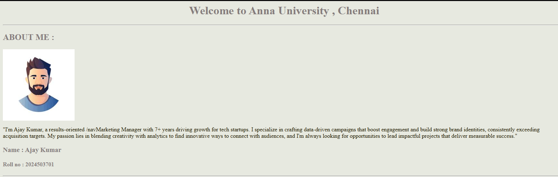
Figure(a): <h1>, <hr>, <p>, <img>

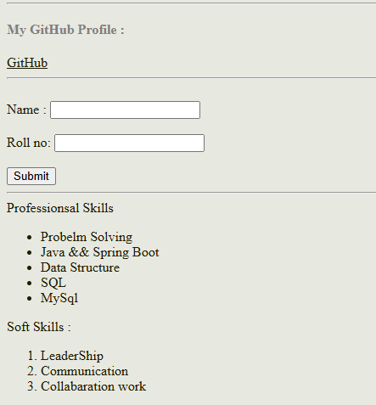
Figure(b): <a>, <hr>, <label>, <button>, <input>

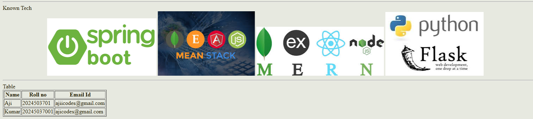
Figure(c): <marquee>, <hr>, <label>, <table>

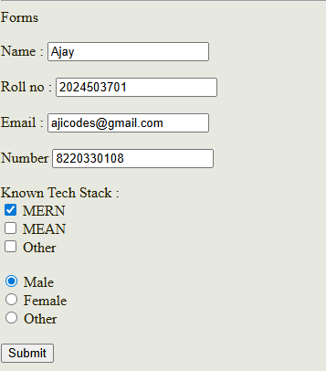
Figure(d): <forms>, <input>, <label>, <button >

Figure(e): Using Get method in forms

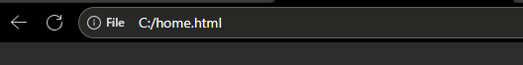
Figure(f): Using Post method in forms

Result:
Thus, a functional and visually structured basic webpage was successfully designed using HTML and CSS. The page includes headings, images, links, forms, tables, lists, and styled elements demonstrating fundamental web-design concepts.

